**CSE 3241 Activity – Relational Algebra II**

Name : Lohith Maralla Date: 2/20/22

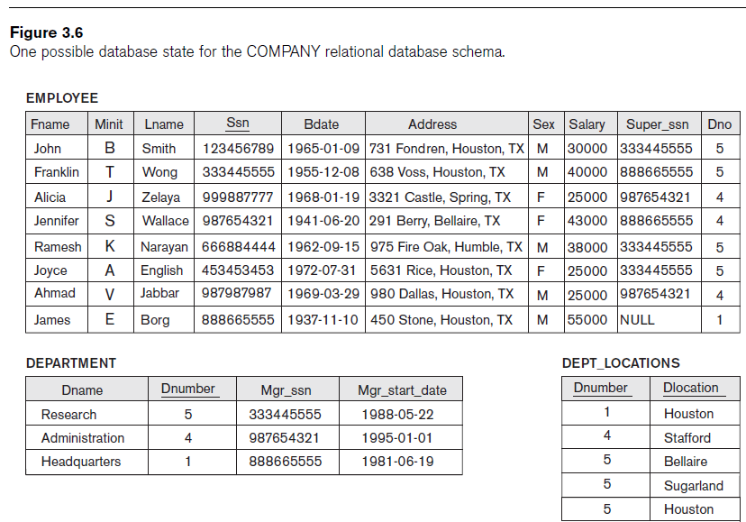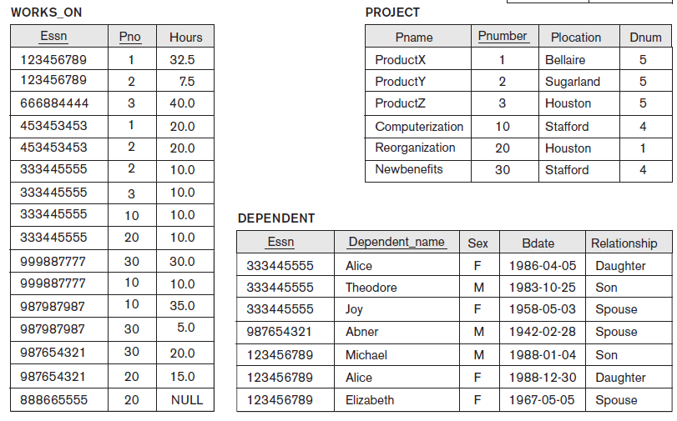

Given the above database, and the primary/foreign keys used for it as discussed in the course slides, specify how you would write the following queries using relational algebra notation.

1. Retrieve the first name, last name, salary, and department number for all employees.

Sigma_Fname(Sigma_Lname(Sigma_Salary(Sigma_dno))EMPLOYEE)

1. For the department named “Administration”, retrieve the first name, last name, and salary of each employee working for the department

Pi_Fname,Lname,Salary(EMPLOYEE)

Where Dname = “Administration”

1. Retrieve the employee last name, dependent first name, and relationship of dependents of employees who work in the department named ‘Research’

Pi_Lname, Dependent_Name,Relationship(EMPLOYEE)

Where Dname = “Research”

1. Retrieve a list of the names of employees in the ‘Research’ department and the names of the projects they are assigned to.

Pi_Fname, Lname, Pname(EMPLOYEE)

Where Dname = “Research”

1. Retrieve the employee first name, last name, department number, and supervisor last name for all employees. Your query should include all employees, including those with no supervisor.

Pi_Fname, LName, Dno(EMPLOYEE)

1. Retrieve the employee first name, last name, department number, and supervisor last name for all employees who have a salary that is at least $30,000 but is less than $50,000.

Sigma_Fname(Sigma_Lname(Sigma_Dno)EMPLOYEE)

Where salary >= 30000 && salary < 50000

1. Retrieve the average salary over all employees in the company.

Pi_avg(salary)(EMPLOYEE)

1. Retrieve the average salary for each department in the company (report by department number).

Dno_GammaAVG Salary(EMPLOYEE)